The French and Indian War
Part 4- Tensions Rise

-By 1750, there were about ________ French colonists living in North America. In comparison, there were over _________ British colonists.

-The ________________________ made plans to help settle British colonists west of the Appalachian Mountains in the _____ River Valley.

-The __________ also claimed the land in the Ohio River Valley.

-To stop the _________ colonists from moving into the Ohio River Valley, the French started building ________ in the area.

-In 1753 the French built _____________________ (Erie, PA) and __________________ (Waterford, PA).

-Fort __________ was built in 1754 by the French near the junction of __________________ and the Allegheny River.

-In 1754 they built ___________________ where the Allegheny and Monongahela Rivers meet to form the _______ River. (Pittsburgh, PA)

-The governor of the ___________ colony, Robert Dinwiddie, wanted the _______ of the Ohio River Valley for Virginia.

-Dinwiddie sent a young man from the British army named _________
_______________ to Fort Le Boeuf to tell them to _________. The French __________.

-Several months later, ________________ was sent back to the area with ____________ to protect British colonists in the area and drive the ___________ out.

-Worried about being ___________ by a larger French force from Fort Duquesne, Washington built ________________ for protection.

-On July 3, 1754, the French did attack, laid _________ to the fort, and forced Washington to ______________.

-Washington and his troops returned to Virginia. Many say this was the beginning of the ____________________________.

-Several British colonists understood that like the _____________ they would be better off if the British colonies worked ___________.

-One of these was a Philadelphia printer named _________________. He printed the first political cartoon in America titled ____________ to make the point that the British colonies should join together for their mutual defense.
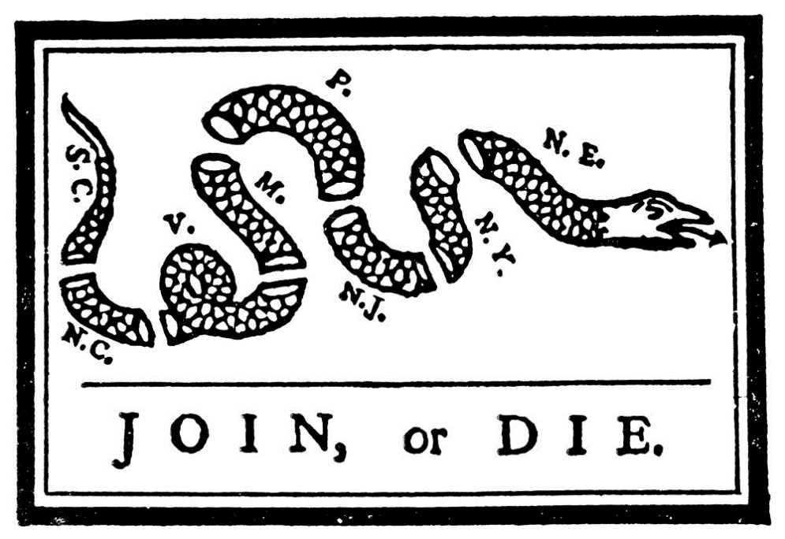

-So in 1754, colonial leaders from ____________ colonies, along with many Iroquois leaders met in _____________ and formed the Albany Congress to form a _________ of union.

-However, the colonies ___________ the Albany Plan of Union because none of the colonies wanted to give up power to a _________ government.

